NAME : VAIBHAV DILIP BEGDE
ROLL NO: 2501014

Academic Year 2025-26
Course - IT22 Full Stack Development
React JS – Hands on Assignment -1

1. Create a Simple React App Display “Hello, World!” inside an tag.
import logo from './logo.svg';
import './App.css';

function App() {
return <h1>Hello, World!</h1>;
}
export default App;
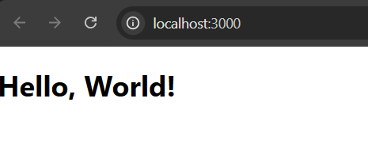

2. Write JSX to Display a Paragraph Inside a , display a tag with your name.

import logo from './logo.svg';
import './App.css';

function App() {
return (
<div>
<p>My name is Vaibhav</p>
</div>
);
}
export default App;

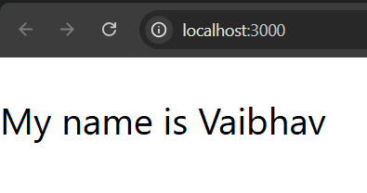

3. Create a JSX expression that renders the current date and time dynamically.

import logo from './logo.svg';
import './App.css';

function App() {
return <h3>{new Date().toLocaleString()}</h3>;
}
export default App;
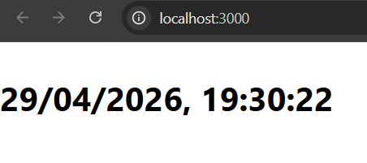
4. Create a simple functional component that returns a heading

import logo from './logo.svg';
import './App.css';

function Heading() {
return <h2>This is a Heading</h2>;
}
export default Heading;
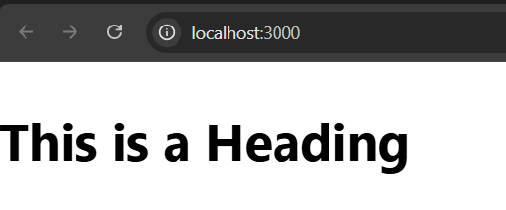
5. Write a program to demonstration of nested functional component

import logo from './logo.svg';
import './App.css';
function Child() {
return <p>Child Component</p>;
}

function Parent() {
return (
<div>
<h2>Parent Component</h2>
<Child />
</div>
);
}

export default Parent;

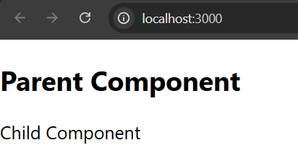

6. Create a parent component that passes a name prop to a child component and displays it.

import logo from './logo.svg';
import './App.css';
function Child(props) {
return <h3>Hello {props.name}</h3>;
}
function App() {
return <Child name="Vaibhav" />;
}
export default App;

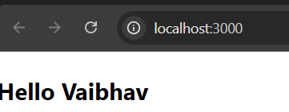
7. Create an array of students which includes roll number, name and age pass it as a props to functional component and display all information.

import './App.css';
function Students({ data }) {
return data.map((s) => (
<p key={s.roll}>
{s.roll} - {s.name} - {s.age}
</p>
));
}

function App() {
const students = [
{ roll: 2501014, name: "vaibhav", age: 22 },
{ roll: 2501030, name: "pruthviraj", age: 23 },
];

return <Students data={students} />;
}

export default App;

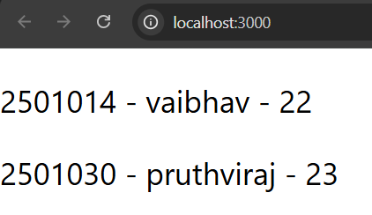
8. Pass an array of colors (as props) to a child component and render them as • items.

import './App.css';
function Colors({ colors }) {
return (
<ul>
{colors.map((c, i) => (
<li key={i}>{c}</li>
))}
</ul>
);
}

function App() {
return <Colors colors={["Red", "Blue", "Green"]} />;
}
export default App;

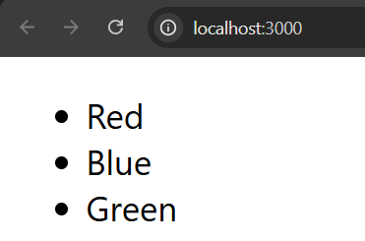
9. Build a counter with two buttons (+ and -) to increment/decrement a state variable

import './App.css';
import { useState } from "react";

function App() {
const [count, setCount] = useState(0);
return (
<>
<h2>{count}</h2>
<button onClick={() => setCount(count + 1)}>+</button>
<button onClick={() => setCount(count - 1)}>-</button>
</>
);
}
export default App;
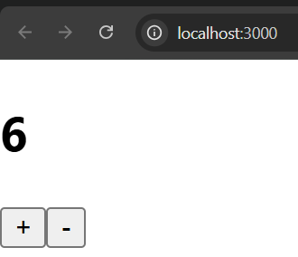

10. Create an input field that logs its value to the console on every keystroke (use onChange).

import './App.css';
import { useState } from "react";
function App() {
return (
<input
type="text"
onChange={(e) => console.log(e.target.value)}
/>
);
}
export default App;
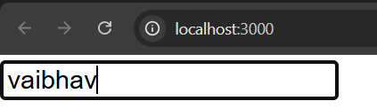

11. Create a button that changes its background color when clicked (use onClick and state).

import './App.css';
import { useState } from "react";

function App() {
const [color, setColor] = useState("blue");

return (
<button
style={{ background: color }}
onClick={() => setColor("green")}
>
Click Me
</button>
);
}
export default App;
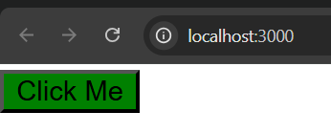
12. Build a form with name and email fields that alerts the submitted values (use onSubmit).

import './App.css';
import { useState } from "react";

function App() {
const [name, setName] = useState("");
const [email, setEmail] = useState("");

const handleSubmit = (e) => {
e.preventDefault();
alert(name + " " + email);
};

return (
<form onSubmit={handleSubmit}>
<input onChange={(e) => setName(e.target.value)} />
<input onChange={(e) => setEmail(e.target.value)} />
<button type="submit">Submit</button>
</form>
);
}
export default App;

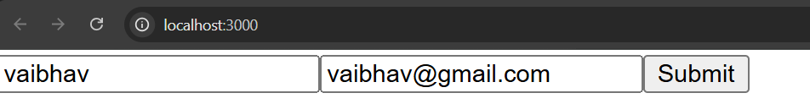

13. Add a button that disables itself after 3 clicks (use state to track clicks).

import './App.css';
import { useState } from "react";

function App() {
const [count, setCount] = useState(0);

return (
<button
disabled={count >= 3}
onClick={() => setCount(count + 1)}
>
Click {count}
</button>
);
}
export default App;

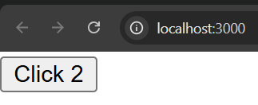
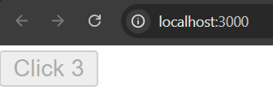
14. Implement a dropdown that updates state with the selected value

import './App.css';
import { useState } from "react";

function App() {
const [value, setValue] = useState("");

return (
<>
<select onChange={(e) => setValue(e.target.value)}>
<option>Choose</option>
<option>React</option>
<option>Java</option>
</select>
<p>{value}</p>
</>
);
}
export default App;

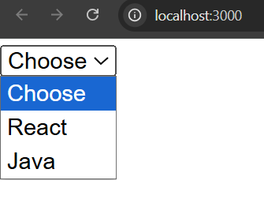
15. Build a AADHAR Registration form with an input field and a submit button.

import './App.css';
function App() {
return (
<form>
<input placeholder="Enter Aadhar Number" />
<button>Submit</button>
</form>
);
}
export default App;

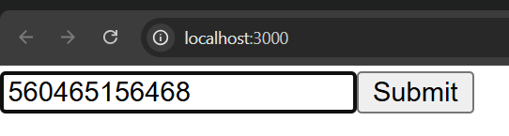
16. Add Form Validation in above program.

import './App.css';
import { useState } from "react";

function App() {
const [aadhar, setAadhar] = useState("");

const handleSubmit = (e) => {
e.preventDefault();
if (aadhar.length !== 12) {
alert("Invalid Aadhar");
} else {
alert("Valid");
}
};

return (
<form onSubmit={handleSubmit}>
<input onChange={(e) => setAadhar(e.target.value)} />
<button>Submit</button>
</form>
);
}
export default App;

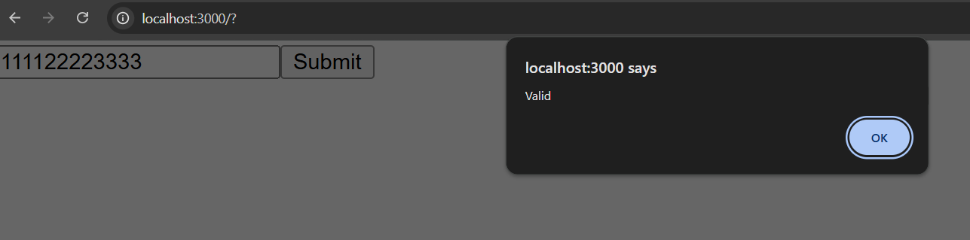
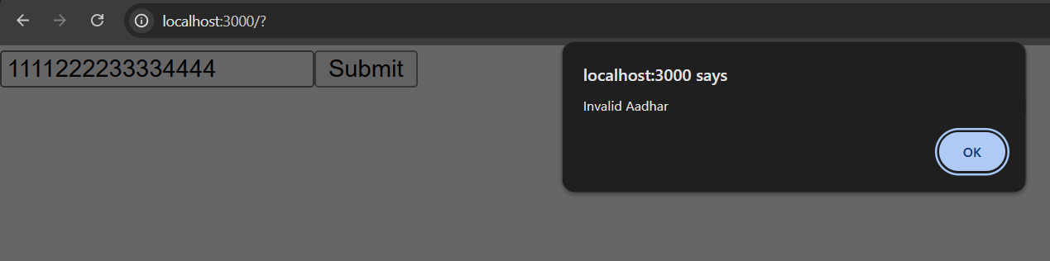

17. Write a program to demonstrate functional component life cycle phases.

import './App.css';import { useEffect } from "react";

function App() {
useEffect(() => {
console.log("Mounted");

return () => {
console.log("Unmounted");
};
}, []);

return <h2>Lifecycle Demo</h2>;
}
export default App;

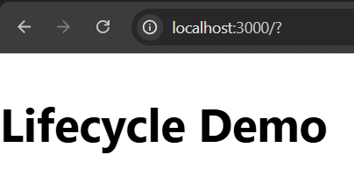
18. Create a timer that updates the seconds elapsed every seconds.

import './App.css';
import { useState, useEffect } from "react";
function App() {
const [sec, setSec] = useState(0);
useEffect(() => {
const timer = setInterval(() => {
setSec((s) => s + 1);
}, 1000);
return () => clearInterval(timer);
}, []);

return <h2>{sec} seconds</h2>;
}
export default App;

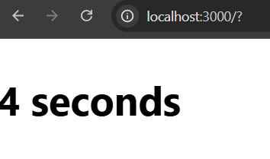

19. Use useState to manage the visibility of a paragraph (toggle text with a button).

import './App.css';
import { useState } from "react";
function App() {
const [show, setShow] = useState(true);
return (
<>
<button onClick={() => setShow(!show)}>
Toggle
</button>
{show && <p>Hello React</p>}
</>
);
}
export default App;

